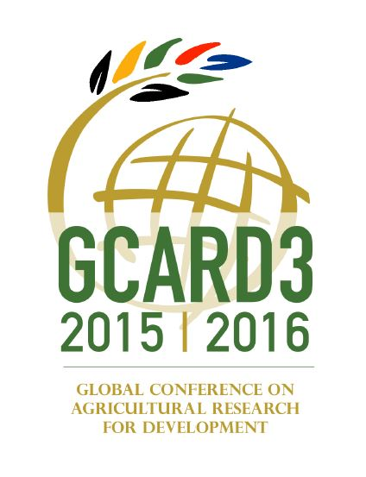
Guidelines for GCARD3 Global Event side events
The GCARD3 Global Event, 5-7 April 2016, in Johannesburg, South Africa is an opportunity for all stakeholders to come together to confirm their commitment to the new sustainable development agenda and to tackle some of the more topical issues emerging in agri-food research and innovation.
The GCARD3 Organizing Committee acknowledges the value of side events to the GCARD3 Global Event and wishes to provide suitable times and spaces for such events. Side events were part of GCARD1 (2010) and GCARD2 (2013) and lessons learned from these indicate that wherever possible, requests for side events be incorporated into the main program so as not to compete with the overall program.
Overall Theme for the GCARD3 Global Event: “No One Left Behind: Agri-food Innovation and Research for a Sustainable World”
The program for the global event is being built on five main themes, which pick up on many issues raised at national and regional GCARD3 meetings through the year:
- Scaling up: from research to impact
- Showcasing results and demonstrating impact
- Keeping science relevant and future-focused
- Sustaining the business of farming
- Ensuring better rural futures
The Program Task Force for the GCARD3 Global Event is responsible for developing and recommending to the GCARD3 Organizing Committee an engaging and informed program under these five themes.
What is a GCARD3 Global Event side event? Requests for side events (those meetings, discussions, consultations) not directly included in the Global Event Program will be considered GCARD3 Side Events. A GCARD3 side event is connected with the GCARD3 on account of its thematic and spatial (Johannesburg-based) proximity. It is however not part of the official GCARD3 Global Event Program.
GCARD3 side events can be held at the GCARD3 Global Event venue (Birchwood Hotel and Conference Center) at the following times and days:
Wednesday 6 April 2016
- Pre-session (e.g. breakfast)
- Post-session (after the final session of the day)

Friday 8 April 2016
- Pre-session (e.g. breakfast)
- Post-session (after the final session of the day)

Side sessions at the GCARD3 Global Event venue will be excluded on Tuesday 5 April and during the lunch breaks on Wednesday 6 April and Friday 8 April.

Why apply? You may consider applying in case your event does not fit the GCARD3 Global Event Program.
How to apply? You need to complete and submit a short application form to the GCARD3 Support Team (gfar-secretariat@fao.org). Rooms for side events at the Birchwood are on a demand basis and cannot be guaranteed until booked; therefore your application should be received as soon as possible. Deadline for side event submissions is 20 March 2016.
Your application will need to specify to what extent the event relates to one of the five GCARD3 Global Event themes, proving its attractiveness for GCARD3 participants. The GCARD3 Communication Task Force and Local Organizing Committee will review your application and advise you if your side event application is approved. Once approved you will be provided with the name and contact details of the Birchwood Hotel and OR Tambo Conference Centre in order to make the arrangements for room, equipment and refreshments (if required).
Obligations Responsibility – Side events' organizers are entirely responsible for the content and organization of the side event and liaise directly with the Birchwood Hotel and OR Tambo Conference Centre for all logistical arrangements and payment. The GCARD3 Organizing Committee, GFAR, CGIAR and the Local Organizing Committee is no way to be considered responsible for an organizational, logistical or content-related incident in relation to the side event.
Logos – Side events' organizers may use the GCARD3 logo as an umbrella logo to accompany their communication, provided it is clearly specified, on each publication/branding element, that the side event is a side event to the GCARD3 Global Event.
Feedback – Whilst applying for holding a side event, organizers agree to give a feedback on the scope and content of their event to the GCARD3 Organizing Committee (attendance, profile of participants, feedback on content).
Target groups – Side events' target groups are largely identical to those of the GCARD3 Global Event and can benefit from the participation of a diverse group of organizations participating in the GFAR Partner Assembly (Tuesday 5 April), the 25th celebration of the Agricultural Research Council of South Africa (Thursday 7 April) and GCARD 3 Global Event (Wednesday and Friday 6 and 8 April, 2016).
e-Visibility – Side events will be granted electronic visibility (GCARD3 website), but no active promotion, except from possible ad-hoc short promotion as part of the GCARD3 communication.
Branding material – Side events' organizers will not receive specific branding material, but can use the generic GCARD3 material made available. The material is available as of 15 February 2016 from the GCARD3 Support Team (gfar-secretariat@fao.org).
Application for GCARD3 Side Event
Please fill in and send to GFAR Secretariat GFAR-Secretariat@fao.org

Contact Person name, phone & e-mail:

Name of organiser:

Name of organization:

Date & time of event:
Wednesday 6 April 2016 (Birchwood Hotel and Conference Center)
Pre-session (e.g. breakfast)
Post-session (after the final session of the day)

Friday 8 April 2016
Pre-session (e.g. breakfast)
Post-session (after the final session of the day)

Title of side event (relevance to GCARD3 must be clear):

Side event description (max. 100 words):

